CPP CHEAT SHEET:
TOC
Key
Fundamentals
Variables & Data
Operators, Conditionals, & Loops
Pointers, References, & Memory
Arrays & Strings
Functions
Structures
Object Oriented Programming (OOP)
Classes & Objects
Encapsulation, Abstraction, Inheritance, & Polymorphism
Standard Template Library (STL)
Containers
Sequential Containers: Arrays, Vectors, Deques, Lists, & Forward Lists
Container Adapters: Stacks, Queues, & Priority Queues
Associative Containers: Sets/Multisets, Maps/Multimaps
Unordered Containers: Unordered Set/Multiset, Unordered Map/Multimap
Algorithms
Sort, Copy, Max Element, Find (remove?), For Each
Range?, distance() (think for iterators)
Iterators
Functors: equal_to, not_equal_to, greater, less, plus, minus

Miscellaneous
Compiling
Concepts
Directives
Errors
Exceptions
Files
I/O
Lambda Functions
Namespaces
Overloading
Templates : Pairs, tuples (include useful template section)
Typedefs

Compiler, linker, make-files, paths, shared libraries, using/creating libraries, debugger, timing code

Variables & Data:
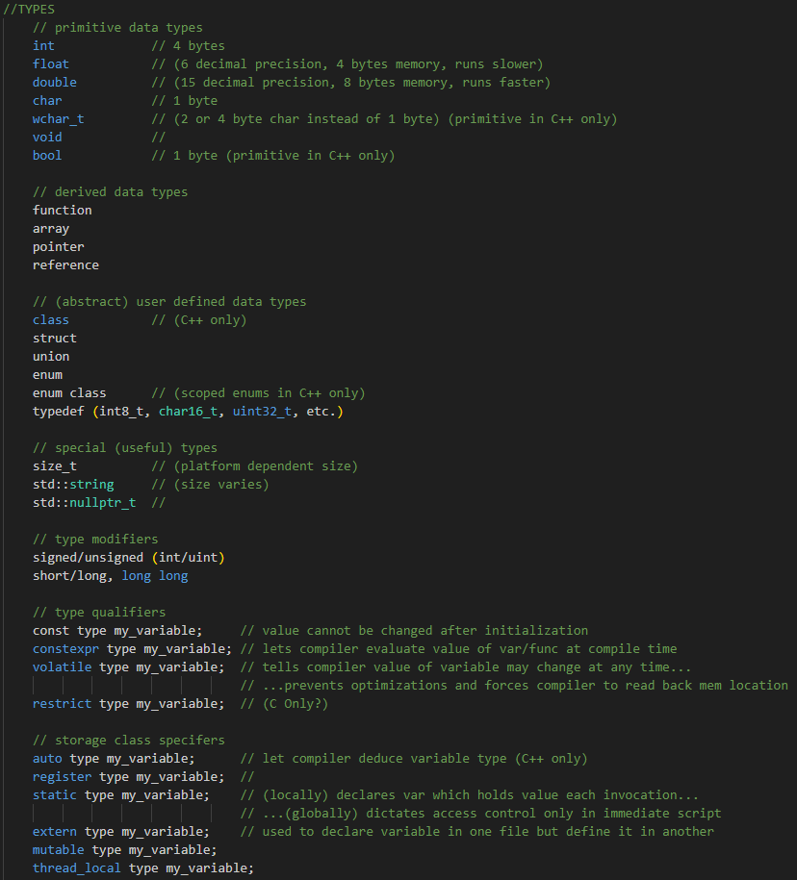

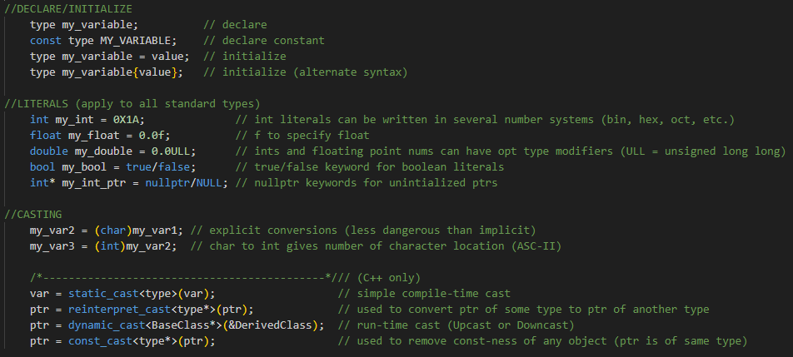

Operators:
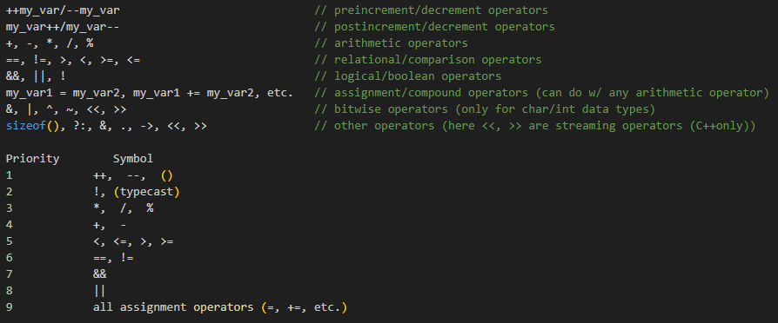
See also operator overloading

Conditionals:
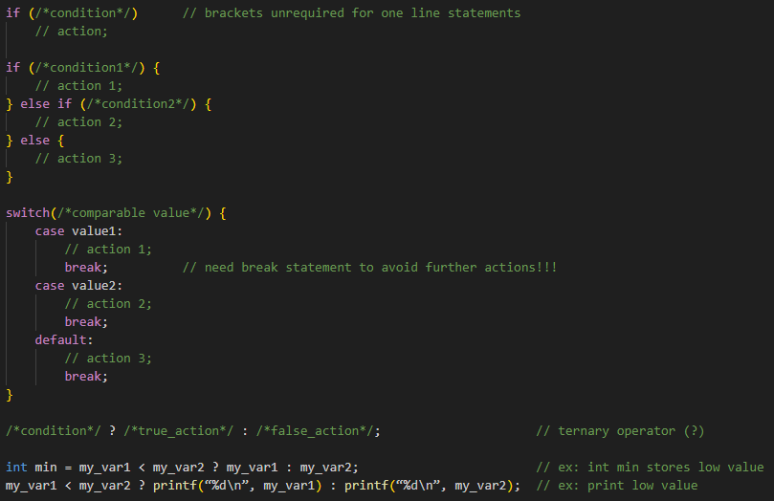
Loops:
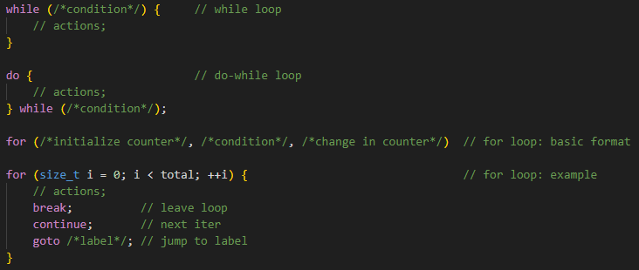>-----------------------------------------------------EXCLUSIVE_TO_C++---------------------------------------------------------
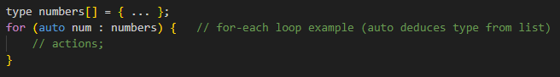-----------------------------------------------------EXCLUSIVE_TO_C++---------------------------------------------------------<
Arrays:
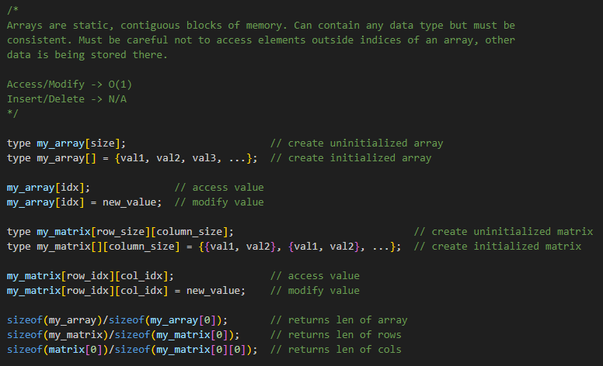
>-----------------------------------------------------EXCLUSIVE_TO_C++---------------------------------------------------------
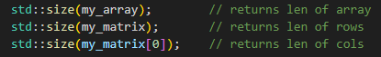
------------------------------------------------------EXCLUSIVE_TO_C++--------------------------------------------------------<

Strings:
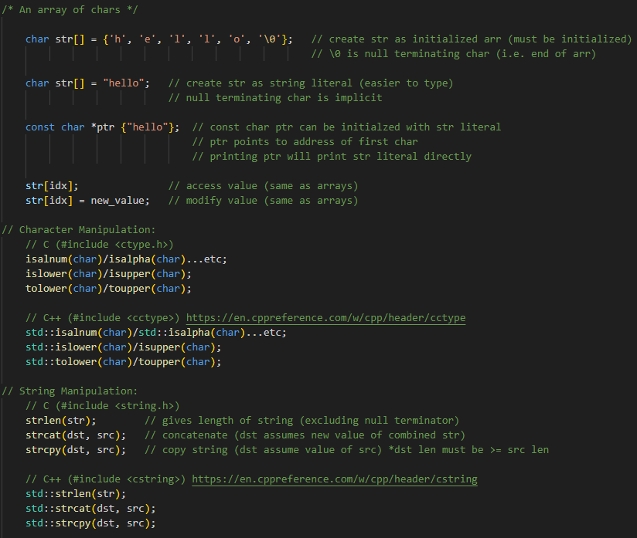
>-----------------------------------------------------EXCLUSIVE_TO_C++----------------------------------------------------------
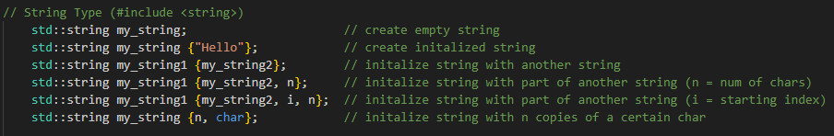
------------------------------------------------------EXCLUSIVE_TO_C++--------------------------------------------------------<

Pointers:
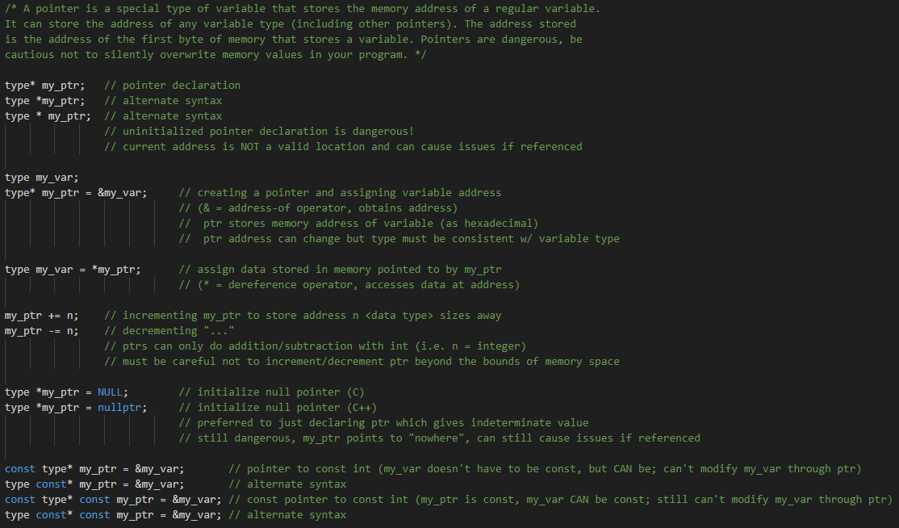
>-----------------------------------------------------EXCLUSIVE_TO_C++---------------------------------------------------------
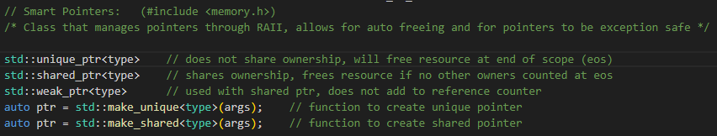
References:
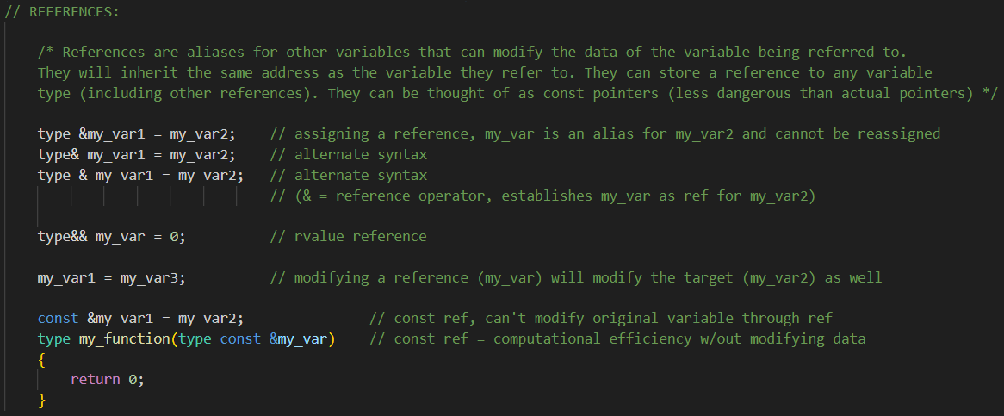
------------------------------------------------------EXCLUSIVE_TO_C++--------------------------------------------------------<
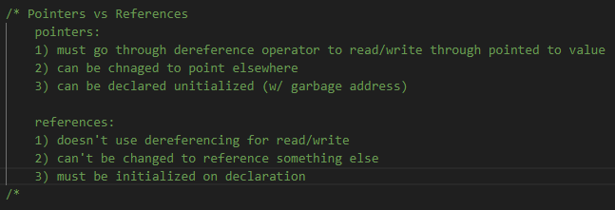

Memory:
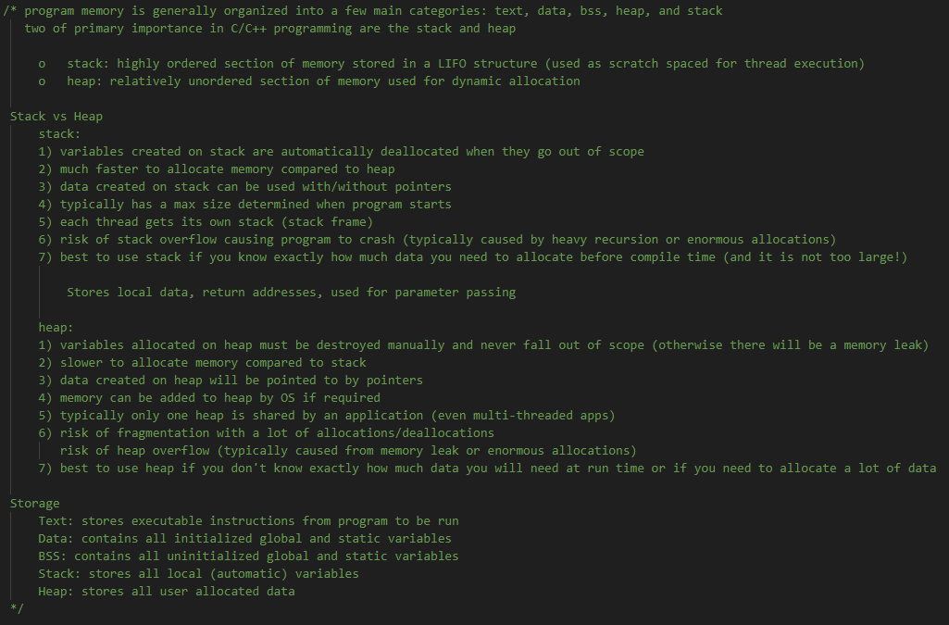
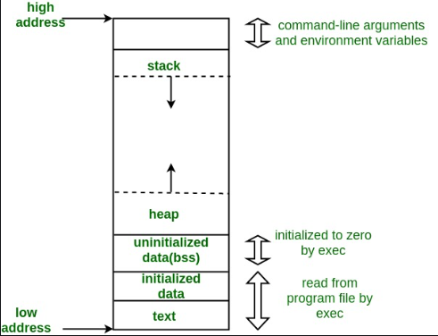

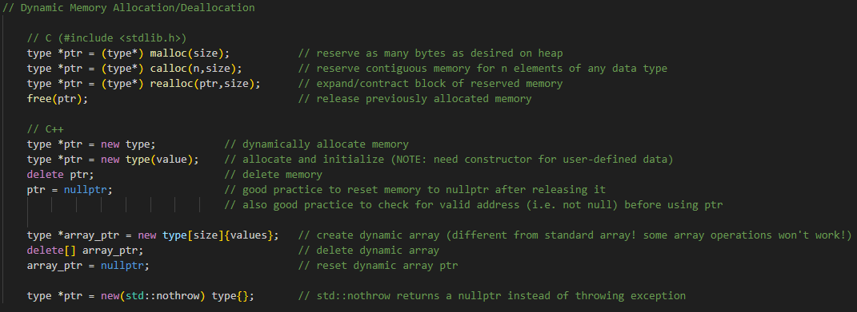

Functions:
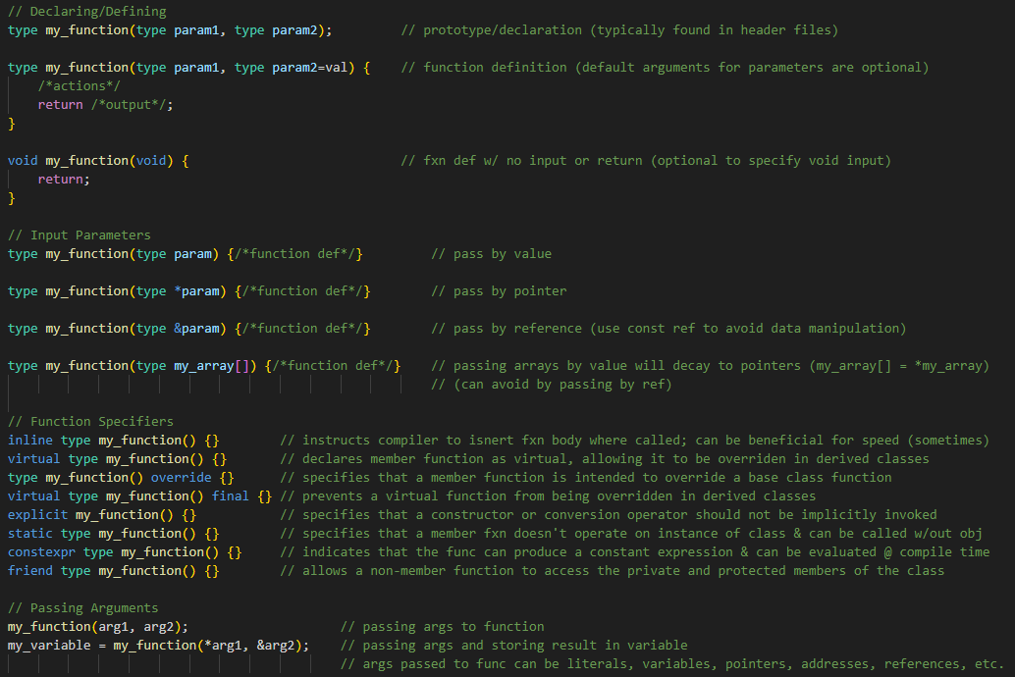
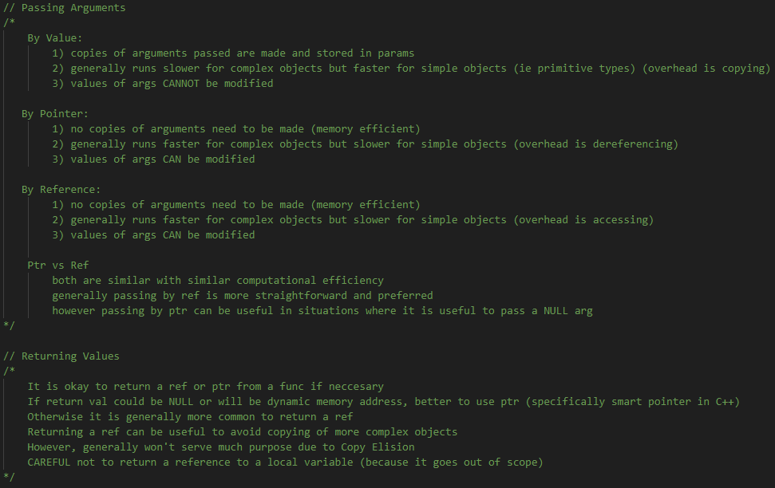 See also function overloading, lambda functions, functors, and function templates (stdlib_functions)
Structures:
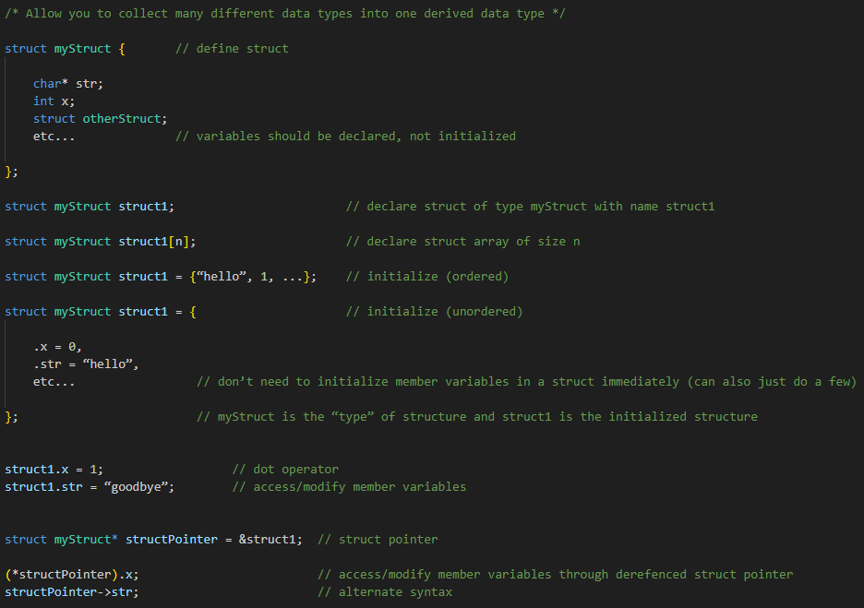

>-----------------------------------------------------EXCLUSIVE_TO_C++---------------------------------------------------------
Classes and Objects:
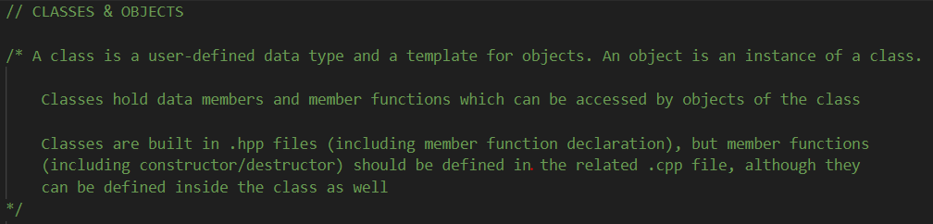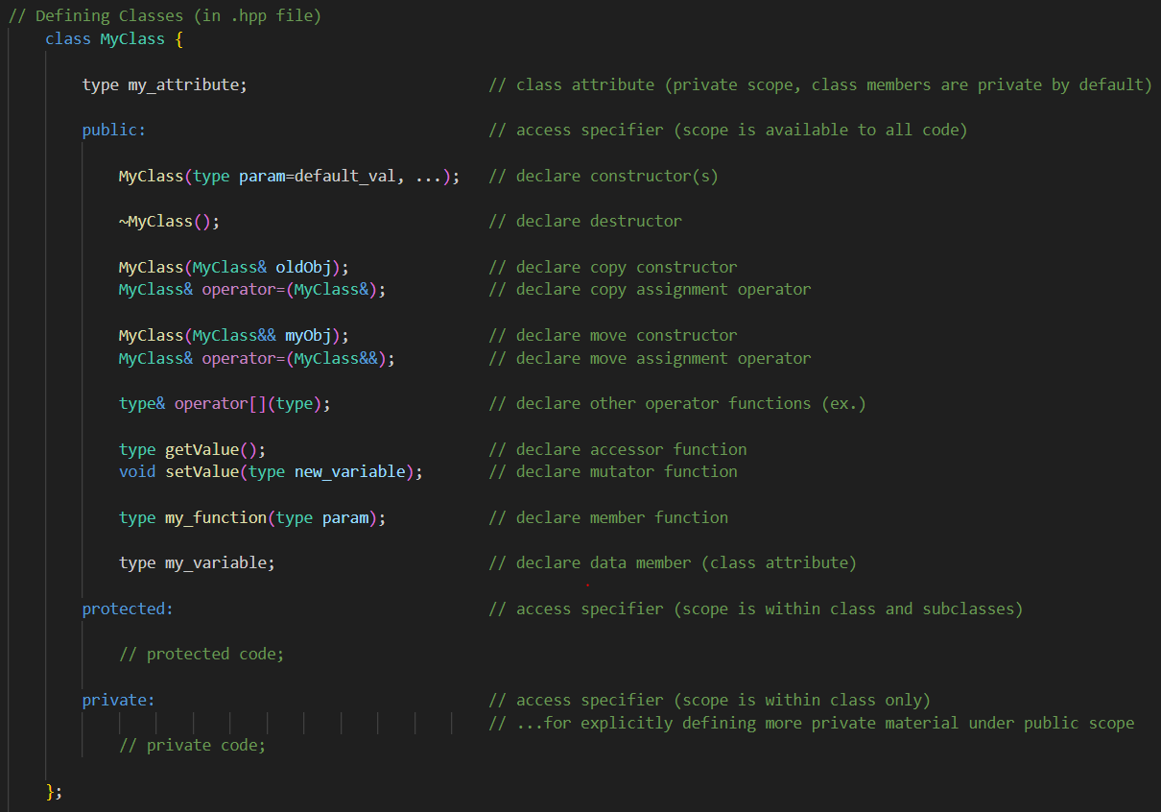

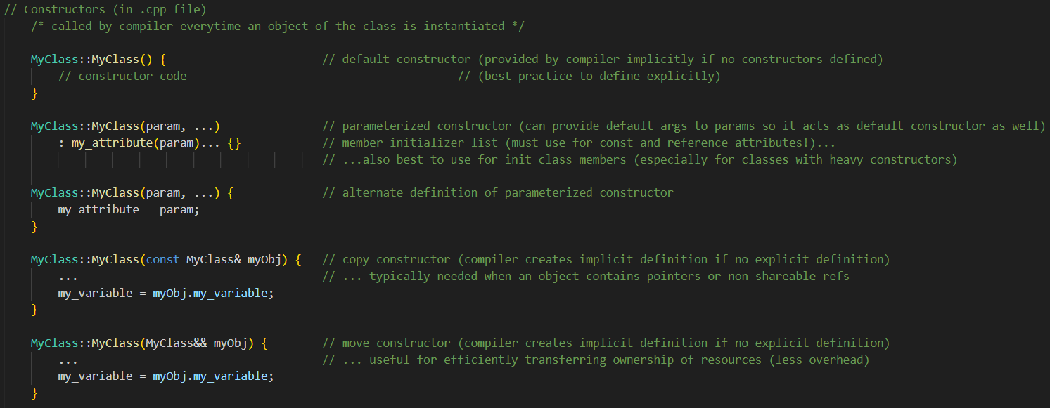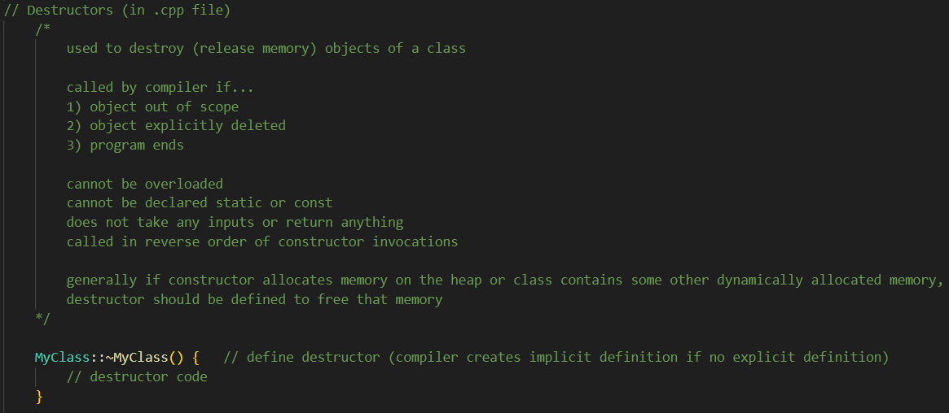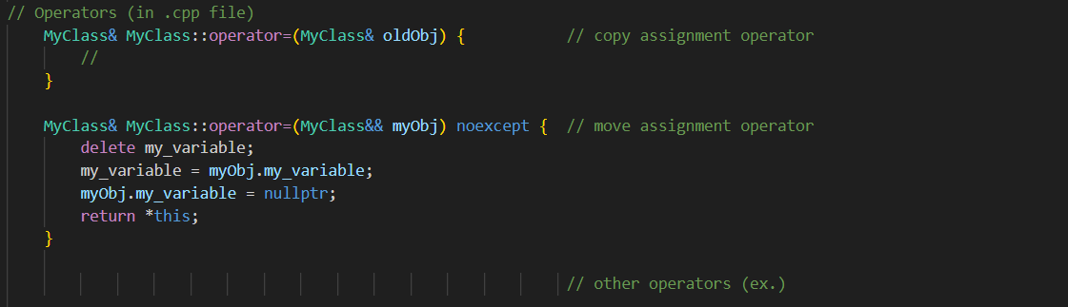
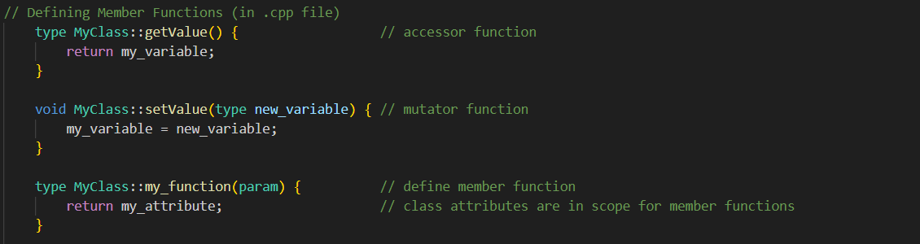

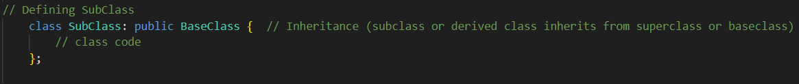
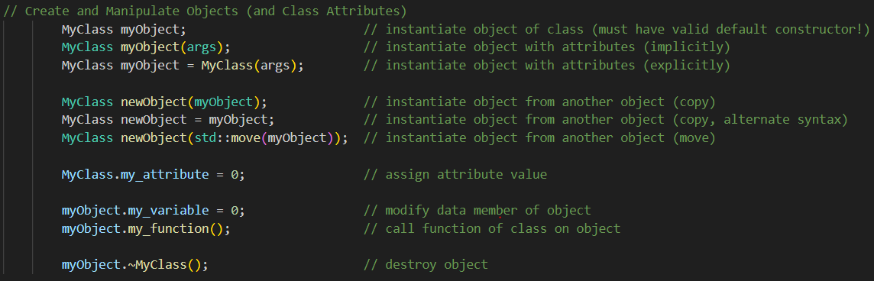
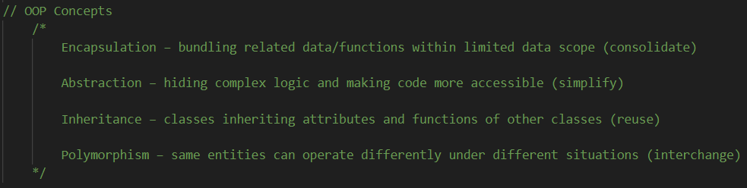
See also class templates

------------------------------------------------------EXCLUSIVE_TO_C++--------------------------------------------------------<
Containers:
>-----------------------------------------------------EXCLUSIVE_TO_C++---------------------------------------------------------

Vectors:
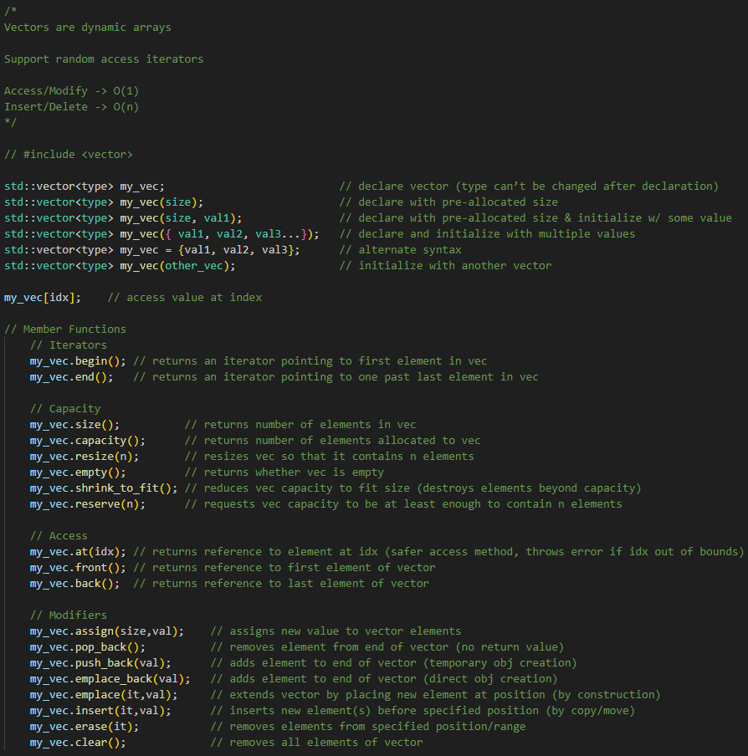

Stacks:
“Container that stores elements in LIFO order. Implemented as container adaptor (a class that uses another container class as its underlying container. The underlying container class can be vector, deque, or list. Default is deque.”
std::stack<type> stackName; // initiate stack
std::stack<type, containerType<type>> stackName; // initiate stack w/ specified container
type must be same, deque is default container type
Useful member functions:
.empty() // returns true if no elements
.pop() // removes last item added to top of stack
.push() // adds element to top of stack
.size() // returns number of elements in stack
.top() // returns element on top of stack

Queues:
“container adaptors that store elements in a FIFO order”
queue<type> queueName; // create queue
Useful member functions: // must include <queue> library
.empty() // checks if queue is empty
.front() // returns next element within queue
.pop() // renoves element at front of queue
.push() // adds element at back of queue
.size() // returns number of elements in queue

Sets:
“associative containers which store unique elements that can be referenced by an element’s value. Values are constant once assigned. Existing values can be removed or new values can be added. Values of set are sorted in ascending order.”
std::set<type> setName; // initiate a set
std::set<type, std::greater<type>> // initiate set with values in descending order
(changed comparison function)
Useful member functions:
.clear() // removes all values from a set
.erase() // removes a single value from a set
.insert() // inserts a single value into a set

Maps:
“data structure that stores a collection of elements formed by a combination of a key value and mapped value”
std::map<keydatatype, valuedatatype> mapName; // creates empty map
std::map<keydatatype, valuedatatype> mapName = {{key1, value1}, key2, value2}, …};
mapName[key] // access elements of map

“comparison function sorts elements by keys in ascending order by default”
std::map<keydatatype, valuedatatype, std::greater<keydatatype>> mapName;
// sort elements in descending order
Useful Member Functions: // include <map> or <unordered_map>
.clear() – removes all elements from map
.erase() – removes an element by key from map
.insert() – inserts a key-value pair into map

------------------------------------------------------EXCLUSIVE_TO_C++--------------------------------------------------------<

Iterators:
>-----------------------------------------------------EXCLUSIVE_TO_C++---------------------------------------------------------
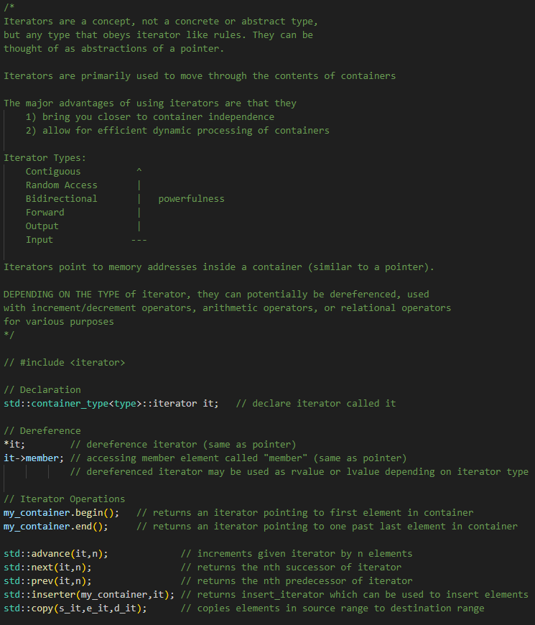
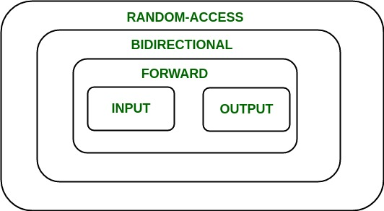
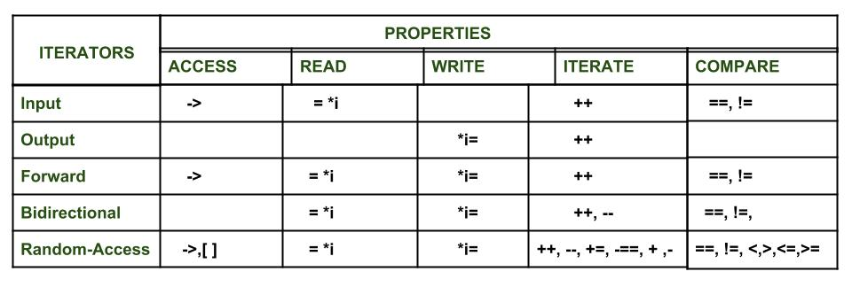
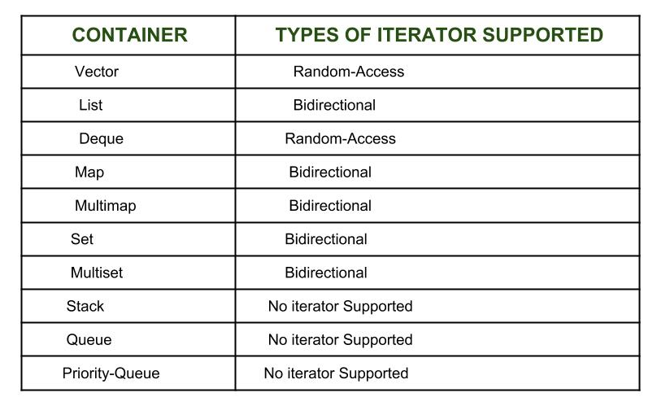
https://en.cppreference.com/w/cpp/iterator
-----------------------------------------------------EXCLUSIVE_TO_C++---------------------------------------------------------<

Functors:
>-----------------------------------------------------EXCLUSIVE_TO_C++----------------------------------------------------------
“Object or Struct that can be called like a function by overloading function call operator ‘( )’ ”
class MyClass {
public:
type operator( )(args) { // defining a functor
// function body
}
}

MyClass myClass; // instantiate object
myclass(args); // calling a functor
-----------------------------------------------------EXCLUSIVE_TO_C++---------------------------------------------------------<

Miscellaneous------------------------------------------------------------------------------------------------------------------------
Compiling:
(note: these are all terminal commands)
gcc script.c // compile command (for gcc compiler) in C
gcc script.c -o scriptname // compile and name output file in C
g++ script.cpp -o scriptname // compile and name output file in C++
./scriptname.out // run script
g++ script1.cpp script2.cpp // link & compile multiple files

Concepts:
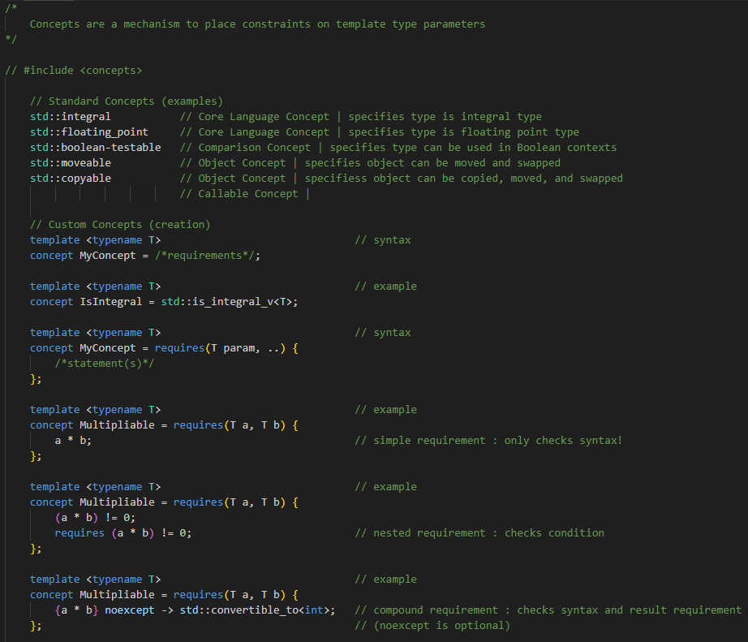
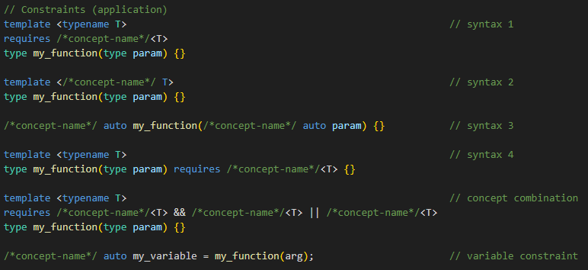
(Pre-Processor) Directives:
Macros
#define MYMACRO // define object-like macro (note: no semicolon)
#define ADD(a, b) (a + b) // define function-like macro
#undef MYMACRO //undefine macro
// Predefined macros
__DATE__ // current date formatted as MMM DD YYYY
__TIME__ // current time formatted as HH:MM:SS
__FILE__ // current filename
__LINE__ // current line number
UINTMAX, etc...

Conditionals
#if / #ifdef / #ifndef // pre-processor conditionals
#elif
#else
#endif

Other:
#import
#include
#line
#pragma
#using

Errors:
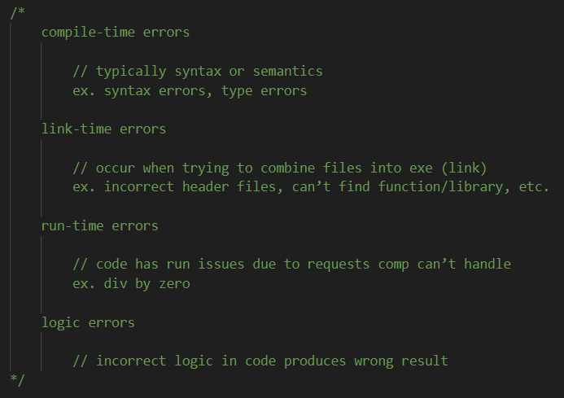

Exceptions:
>-----------------------------------------------------EXCLUSIVE_TO_C++---------------------------------------------------------
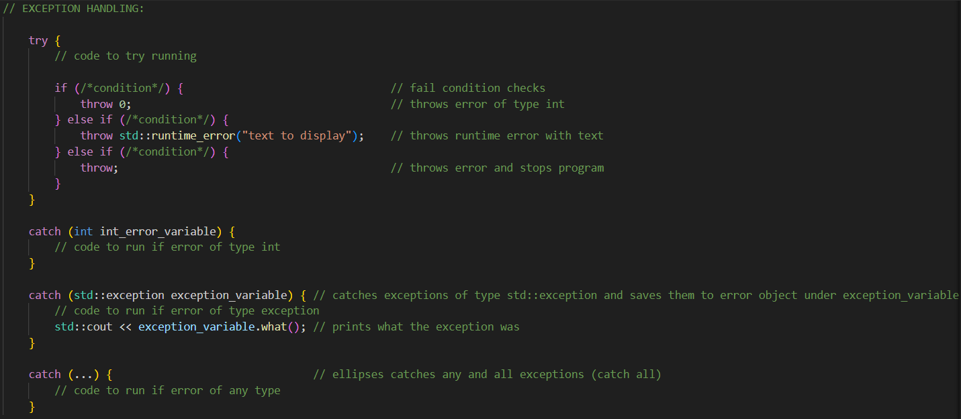-----------------------------------------------------EXCLUSIVE_TO_C++---------------------------------------------------------<

Files:
#include <iostream>
#include <fstream>
classes: ofstream (output file stream), ifstream (input file stream), fstream (combo)
std::ofstream MyFile(“file.txt”); // create and open text file
MyFile << “hello world”; // write to file
MyFile.close(); // close file
std::ifstream MyFile(“file.txt”); // read from file
std::string myString; // create string
getline(MyFile, myString); // output line of file to string

File types: .cc, .cpp, .tpp, .ipp, .hpp, .c, .h, .anythinguwant
file types are mostly a matter of indication of the contents of the file
only source files (i.e. .cpp) are compiled
certain compilers may need correct file extensions?

I/O:
printf("string to display", [list of optional parameters])
sprintf()
scanf()
symbol | type |  | symbol | effect
%d or %i | int |  | \n | newline
%f | double or float |  | \r | carriage return
%c | char |  | \t | tab
%s | string
%p | pointer

>------------------------------------------------------EXCLUSIVE_TO_C++--------------------------------------------------------
#include <ios>,
std::cout << “HelloWorld\n”; // print to terminal
std::cout << variable << endl; // print variable to terminal
std::cin >> variable; // request user input and assign to variable

#include <ios>, #include <iomanip>
std::endl
std::flush
etc…
------------------------------------------------------EXCLUSIVE_TO_C++--------------------------------------------------------<

Lambda Functions:
>----------------------------------------------------EXCLUSIVE_TO_C++----------------------------------------------------------
-----------------------------------------------------EXCLUSIVE_TO_C++---------------------------------------------------------<

Namespaces:
>----------------------------------------------------EXCLUSIVE_TO_C++----------------------------------------------------------
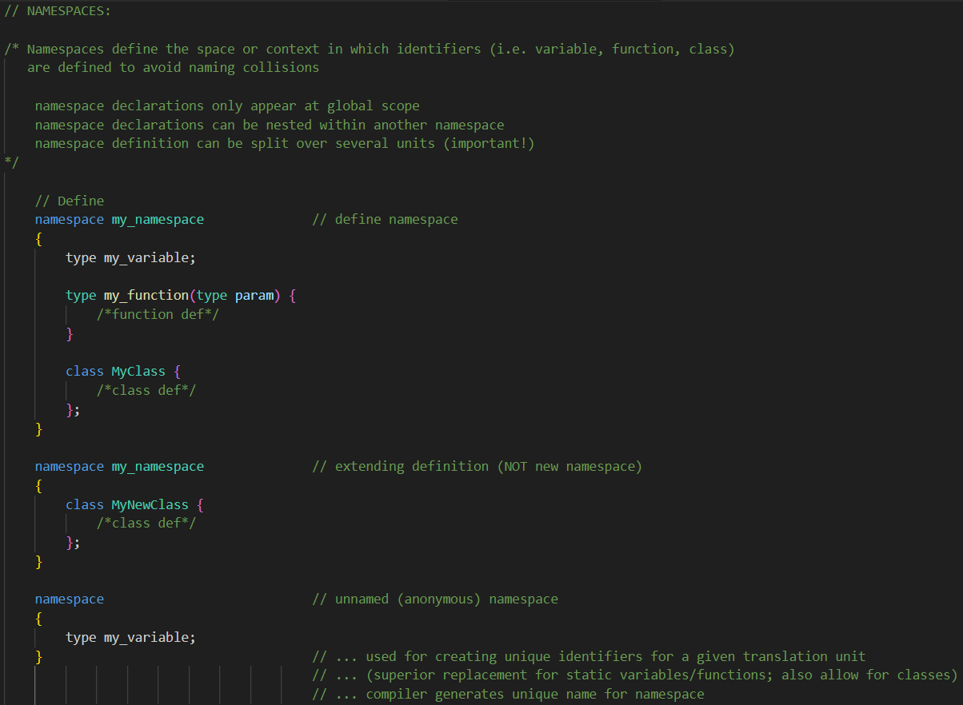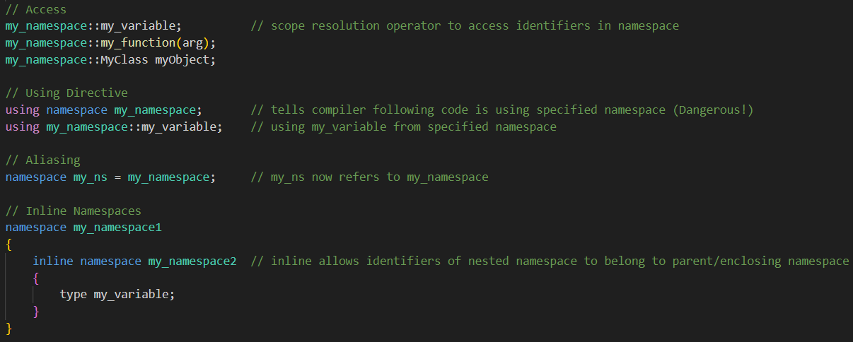-----------------------------------------------------EXCLUSIVE_TO_C++---------------------------------------------------------<

Overloading:
>-----------------------------------------------------EXCLUSIVE_TO_C++---------------------------------------------------------
Operator Overloading
- Operator overloading allows for re-defining of built-in operators as user-defined classes.
- Compiler will determine correct definition of overloaded operator to use based on args
- ? (ternary), :: (scope resolution), and . or .* (member access) operators CANNOT be redefine
- Can only be overloaded within Classes

class className {
public:
returnType operator symbol (args) {
// redefine
}
}

Function Overloading
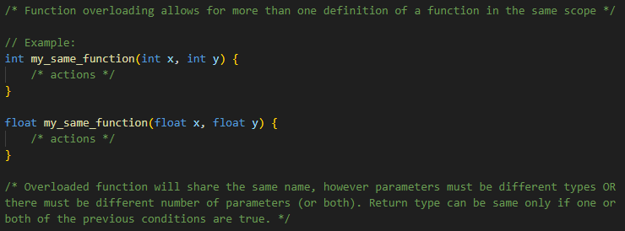-----------------------------------------------------EXCLUSIVE_TO_C++---------------------------------------------------------<

Templates:
>------------------------------------------------------EXCLUSIVE_TO_C++--------------------------------------------------------
Function Templates
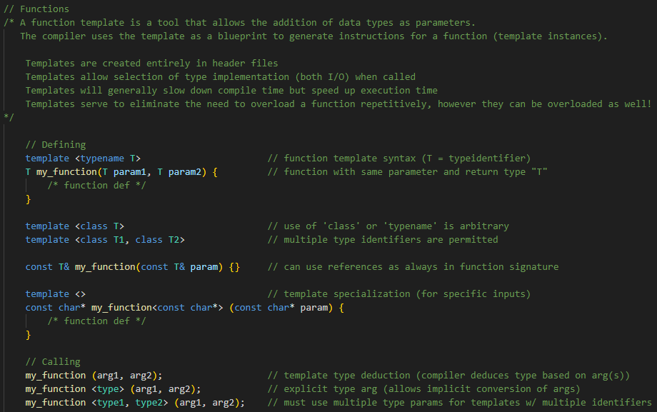
Class Templates
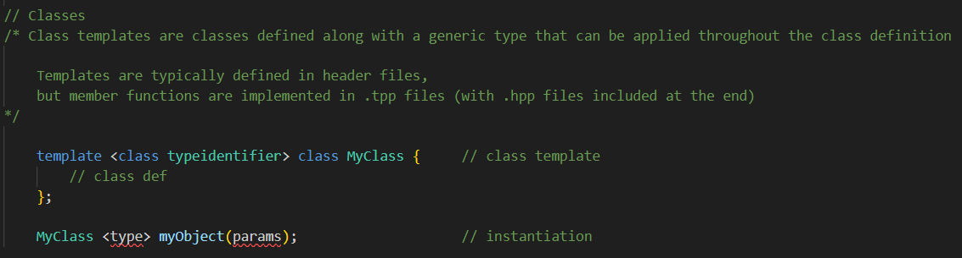------------------------------------------------------EXCLUSIVE_TO_C++--------------------------------------------------------<

Typedefs:

C main script template:

# include <header.h> // standard libraries
# include “header.h” // project files

# define alias value // macros
# define alias calculation

typedef dataType alias // type aliases
typedef returnType alias(paramType);

type my_function (param1Type, param2Type, etc.); // prototypes
…
…

varType varName; // global variables
static varType varName; // static global variables
…
…

int main(int argc, char** argv) { // main function
}

void my_function(void) { // other functions
}

